**COMP30027 Machine Learning, 2020 Semester 1**

Assignment 1: Naive Bayes Classifiers

Student Names: Yue Peng; Tian Qiu

Student IDs: 958289; 988121

## Baisc Implementation

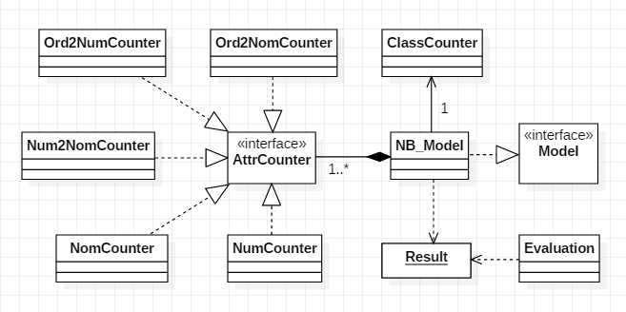

We construct our program using an object oriented way. The Naive Bayes model implements the Model interface where we define the preprocess(), train() and predict() function. We leave the evaluate() function to an evaluation class which can also draw graphs and charts other than simply output statistics. The evaluation class takes a Result object(e.g. [(truth value, predict value)...]) generated from the predict() function of the model class, processes the result and tells us how the model performs.

A NB_Model contains a single ClassCounter and several AttrCounters. They are the basic calculation units to read and counter classes/attributes in the preprocess stage, calculate the probability of classes/attributes in the train stage, and finally return the probability for a specific value in the predict stage. Attribute counters consist of:

* NomCounter - for nominal attributes
* NumCounter - for numeric attributes
* Num2NomCounter - to convert numeric attributes to nominal attributes (Discretisation)
* Ord2NomCounter - to convert ordinal attributes to nominal attributes
* Ord2NumCounter - to convert ordinal attributes to numeric attributes

## Discretizing the Numeric Attributes

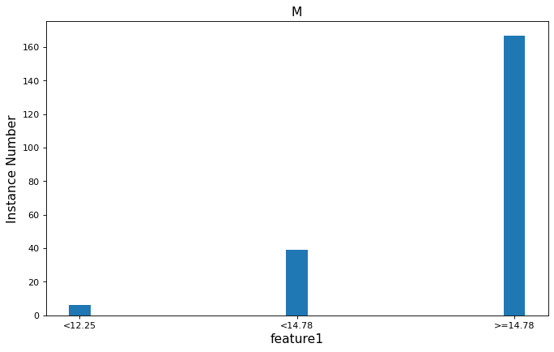

We use the equal frequency method to discretise numeric attributes. These graphs above illustrate the feature1(the first feature)’s distribution among “M” class in the wdbc dataset.

The bar chart on the top shows the raw data distribution, with a normal distribution constructed on the data presented by the graph on the right . The bottom chart illustrates the data equally splitted into 3 distributed over class “M”.

The normal distribution describes the raw data distribution better in terms of the discretization. Whereas, the 3-fold distribution only informs us how many instances in each interval, and it can not depict the raw distribution. Thus, the entropy in the 3-fold distribution model is low because it knows little about the data, and as a result the discretization would actually worsen the performance of the model.

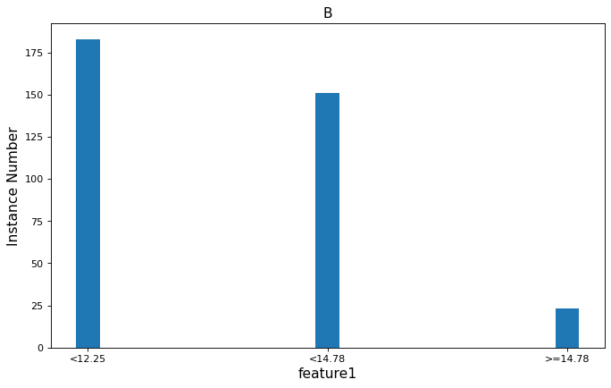

But in fact, discretization does not impose much negative impact on the performance of the model. We get 0.940246 accuracy in no discretisation result and 0.938489 accuray in discretisation result, and the recall/precision is also very close. Why are the accuracy so close? Actually, the model already gets enough information from the 3 folds such that they can tell which class the instance belongs to for most attributes. For example, we can clearly tell the distribution of feature 1 among class “M” and class “B” is different from the following graph. If we find feature 1 is less than 12.25 we can be very sure that the instance belongs to class “B”, or if it is greater than 14.78 then it belongs to class “M”.

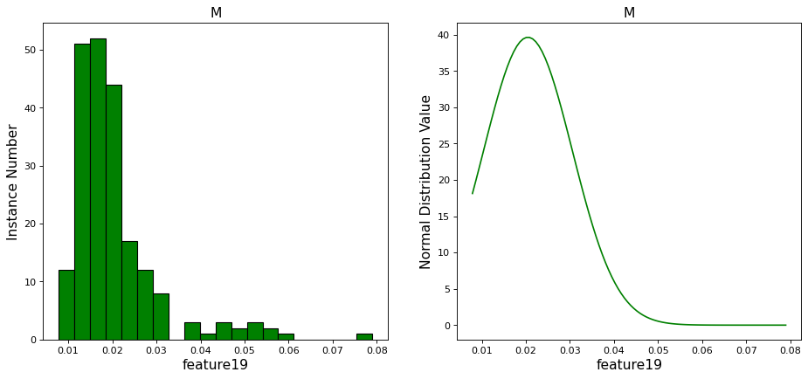

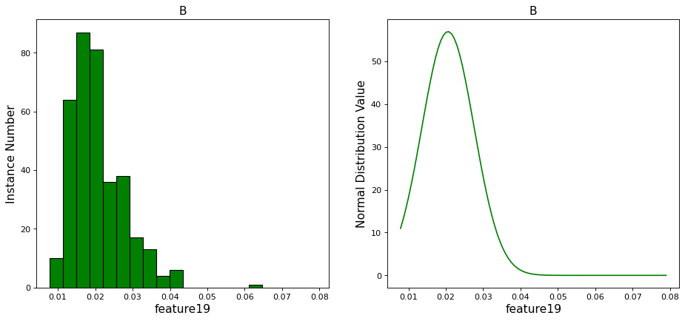

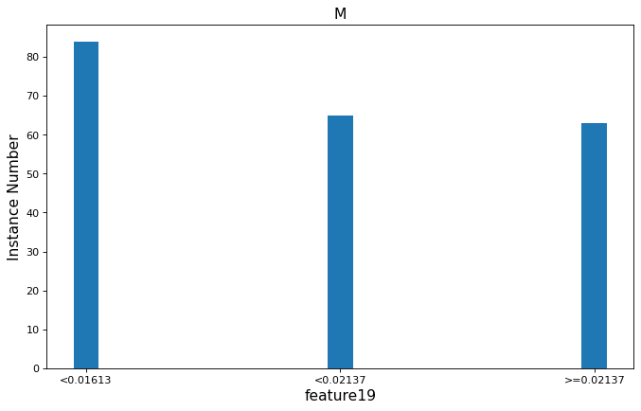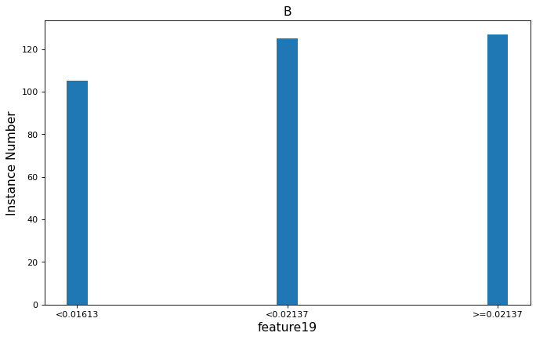

The 3-fold distribution does show its inaccuracy sometimes. In feature 19, the distribution of the 3 folds is quite similar, in other words, we have less confidence to determine which class the instance belongs to for each interval. More specifically, if we found a feature 19 value at 0.05, the instance would probably belong to class ‘M’ , and the normal distribution supports this. However, 0.05 falls in the interval of >=0.02137 where we get class ‘M’ probability less than class ‘B’. So our 3-fold distribution tells us a wrong result by just looking at feature 19.

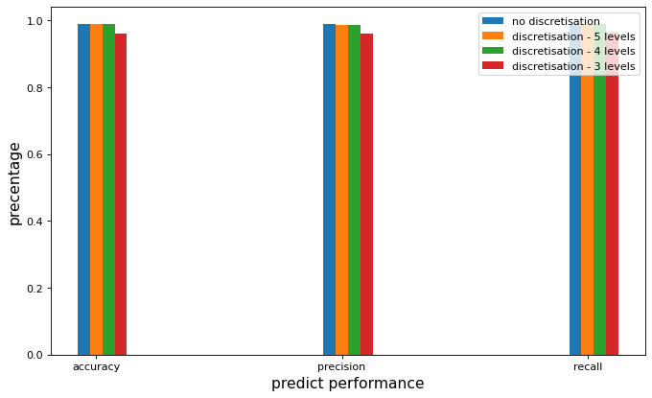

As discussed before, the discretisation method gives correct judges between two classes for most attributes, so the performance does not decrease performance much. Moreover, we also test the wine dataset and the performance differences are shown below. As the number of levels increases, the amount of information increases and the performance also goes up.

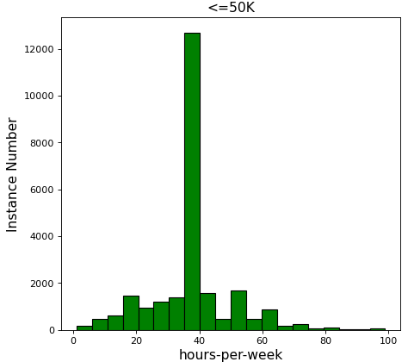

The equal width method might worsen the performance more because it is very sensitive to outliers. But sometimes the equal frequency method does not work. For example, the feature “hours-per-week” in the adult dataset has a dominant value of “40” and when we apply an equal frequency method on it, we would probably get a meaningless interval (40, 40).

## 

## 5. violated Gaussian Assumption

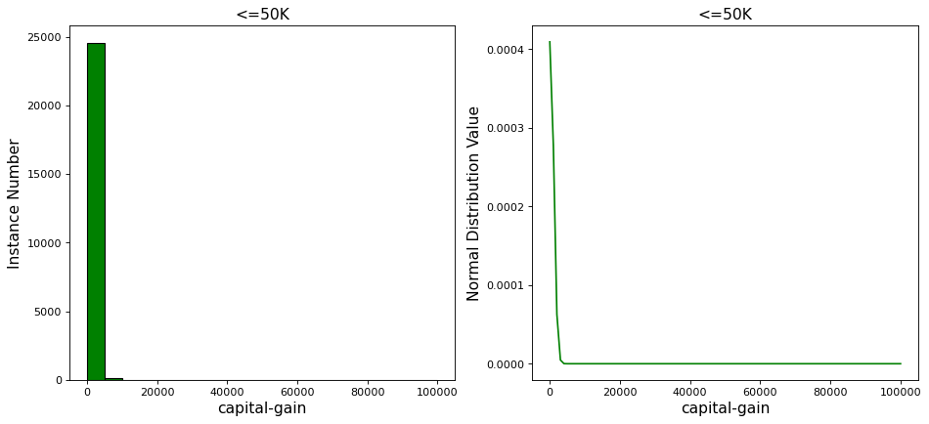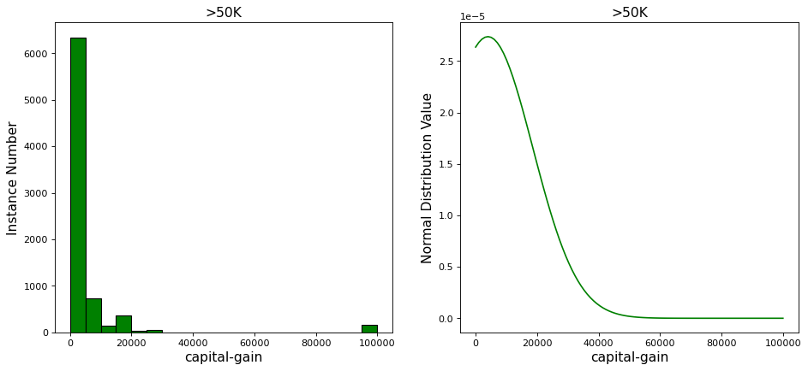

The above distribution is from the feature capital-gain of adult dataset. In both “<=50k” class and “>50k” class almost 90 percent of the instances have 0 capital-gain and a very tiny percentage of them have some capital-gain. Apparently it is inappropriate to apply a Gaussian assumption on it. For most values other than 0, the assumption overestimates the probability.

There is a more dangerous effect. Actually a bunch of rich people have near 100000 capital-gain. If we test the model with such people, the normal distribution function will return 0 for that capital-gain value because it is too extreme, and multiplying by 0 will ruin our Naive Bayes method. So in my implementation, I assign a very small number to replace 0.

In conclusion, if any attribute in the dataset is not naturally distributed and has some extreme outliers, Gaussian assumption could be violated.